1 – Find what I’m going to use to run python, I decided to go for python:alphine since it’s super lightweight

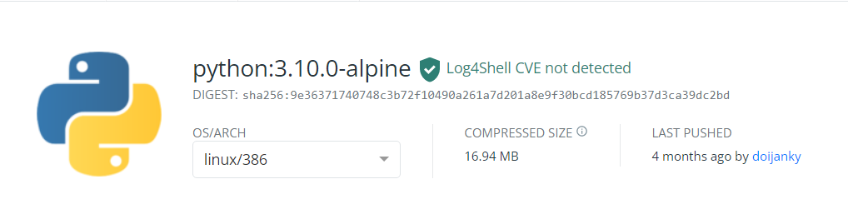Link: <https://hub.docker.com/layers/python/library/python/3.10.0-alpine/images/sha256-9e36371740748c3b72f10490a261a7d201a8e9f30bcd185769b37d3ca39dc2bd?context=explore>

2 – Make a Dockerfile to be able to build this image

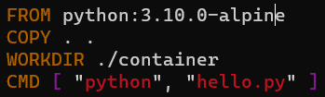

Making it run a file called hello.py inside folder CONTAINER

3 – Making the folder + Python file



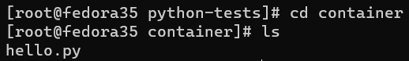

Inside the script there is a simple print:



4 – Building the Dockerfile to an image using the command:

docker build ./ -t python-hello

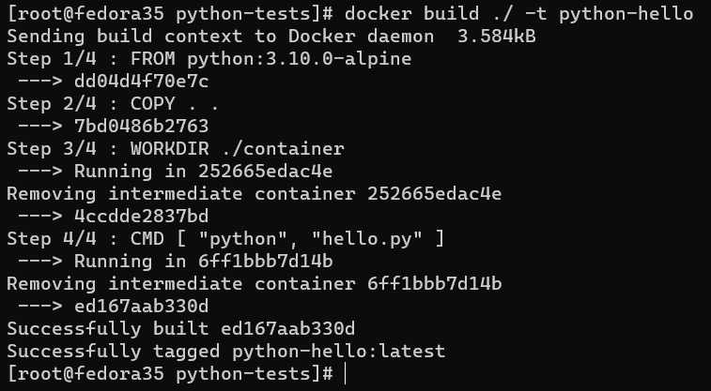

5 – Running the image to a Docker container using the command:

docker run --name python-hello python-hello

